Smart Component Workflow
Technical Documentation
CSLegal Version x.x.x
29.11.2023

Change History
Date | Version | Description | Author
29.11.2023 | 1.0 | Initial revision | GM

Table of Contents
1 Introduction 1
2 Business Case 2
3 Solution 3
4 Design 4
4.1 Design Concept 5
4.1.1 Release Levels 5
4.1.2 Release Level Change UI 5
4.1.3 Smart Component Workflow Data 6
4.1.4 Workflow state machine 7
4.1.5 Workflow 9
4.1.6 Release Levels and Transitions Definition 13
4.1.7 Workflow API 16
5 Operational Concept 19
5.1 Intended Users 19
5.1.1 Smart Components Editors 19
5.1.2 Smart Components Owners (Authors) 19
6 Appendix 20
6.1 AWS Services 20
6.2 Troubleshooting 21
6.3 Outstanding issues of the current implementation 22
6.4 Future developments 23

Introduction
This document gives an overview of the Smart Component Workflow. A Smart Component (herein also abbreviated as SC for convenience), from its creation passes through various states in its workflow life-cycle. This document further elaborates the various services and components involved in this workflow process. The audience of this document are technical users and developers rather than end users. The readers of this document is expected to have a fair knowledge in AWS Cloud Computing.

Business Case
Customers of CSLegal Document Management System use Templates for generating documents for publishing. These templates contain elements that may be commonly useable. Customers need to use these re-useable elements in many templates. Customers also require that the any changes in these re-usable elements reflect in all templates that include these elements. Hence these re-usable elements must have its own CRUD functionality and workflow life-cycle.

Solution
Smart Components were implemented as a solution. Smart Components have its own CRUD functionality and Workflow. This document addresses details relevant to Smart Component workflow only.
SC workflow must be designed to meet following requirements;
  - The workflow must be well-defined
  - The workflow must be stable and recoverable in all stages
  - UI must be available to step through the workflow
  - Customer must be able to;
  - determine release levels and release level names to match to his requirements
  - determine the workflow start release level
  - determine the “released” and “rejected” release level
  - assign permissions to change the release levels
  - assign permissions to perform tasks at each release level
  - re-activate a “rejected” SC

Design
Following design aspects are considered for determining the architecture and required core components and services.
Requirement | Component / Service / Methods
Interaction between components | Use in system commonly used technology such as REST API, graphQL and Web Sockets.  JSON formatted strings are used in requests and responses and payloads by default if not otherwise specified.
Basic release levels | Standard Workflow is designed using basic release levels DRAFT, TO_BE_APPROVED, APPROED and REJECTED
Workflow start release level | Start release level of the Workflow is DRAFT. The smart component automatically inherits this release level at the creation.
Workflow end release level | APPROVED is the successful end release level.  REJECTED is the rejected end release level.
User must be able to step through workflow | Front End application to provide Change Release Level option, API for release level changes,  Smart Component Record fields for store current release level and details, (MongoDB)  Smart Components History Records for release changes (MongoDB)
Stable, mutable and recoverable workflow | AWS Step Functions, SNS, serverless applications and AWS EventBridge
Customizable release-levels and transition permissons. | Entry in the MongoDB workflows collection to define release levels, transition targets and transition permissions.
Access to Workflow API | Over AWS API Gateway using web sockets interface

Design Concept

Release Levels
A workflow state machine with following release levels are set up currently. This workflow is used as the standard workflow.
Release Level | Next release level | Description
DRAFT | TO_BE_APPROVED | DRAFT is the initial release level.
TO_BE_APPROVED | APPROVED or REJECTED
APPROVED, REJECTED | DRAFT | Workflow re-activation

Release Level Change UI
The FE Application contains the release change option for Smart Components in the edit mode.
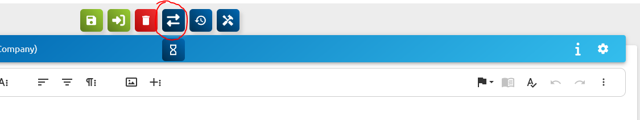
A click on this button display the “sand clock” button underneath. User may see the next possible release by hovering the cursor on this. User can trigger the release level change by clicking on the “sand clock” button, providing a comment and clicking on the “CHANGE TO: ..” button.

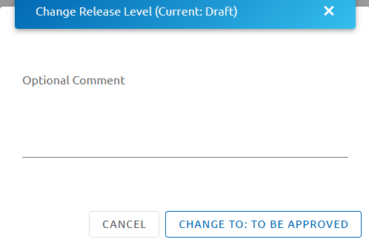

Smart Component Workflow Data
Smart Component workflow related data are stored in the MongoDB Collections
Collection | Data fields | Description
smartComponents | releaseLevelId | Current releaselevel id
smartComponents | history.object  attributes.targetreleaselevel  attributes.releaseLevelComment | In case the history record is generated for a release level change
 | history.object.releaseLevel | Release level of the respective history record
smartComponentsHistory | History Record | Copy of the smartComponents generated for release level changes.

Workflow state machine
AWS Step Functions is used to design the Workflow state machine. The cdk Script that contains the IaC is placed in the script file:
lib/csLegalConstructs/csLegalSmartComponents.ts
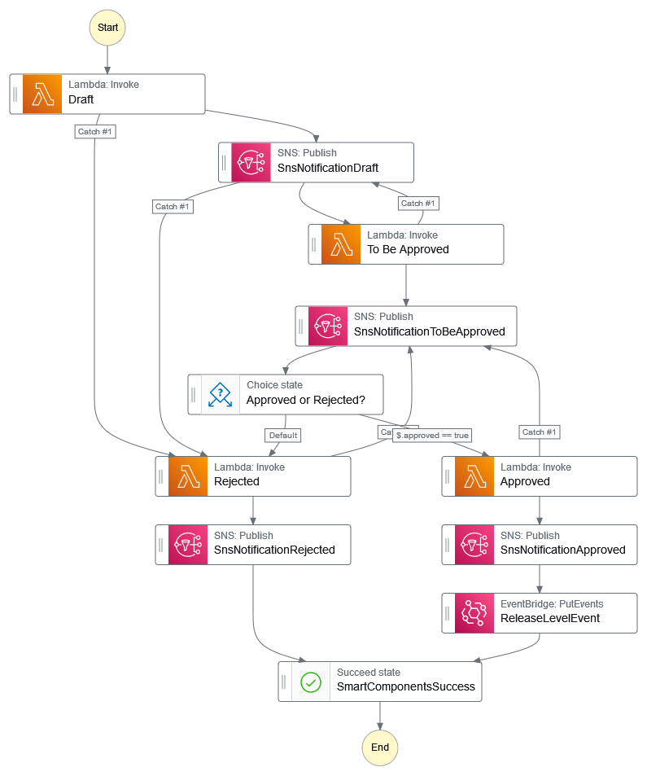

Services used in the workflow

Service | name | Description
AWS Step Functions | Workflow | State Machine (see diagram above)
Lambdas | Components/WebSocketManagementManager | Initial validation of workflow requests, preparatory tasks such as task token fetching.  Calls relevant step function operation.
Lambdas | Components/SmartComponentsManager | Processes workflow request, update smart component record, create smart components history record for if applicable
Lambdas | WebSocketNotifyHandler | Performs post workflow step function tasks task token CRUD
SNS | SnsNotificationDraft  SnsNotificationToBeApproved  SnsNotificationRejected  SnsNotificationApproved | Sends notifications upon completion of each step
EventBridge | ReleaseLevelEvent | Places an event in the CSLegal Event Bus when the Smart Component’s state changes to APPROVED.

Workflow

Workflow initiation
A workflow is initiated in two scenarios:
- User creates a Smart Component; the workflow is automatically initiated
- User restarts the workflow by setting an already approved or rejected Smart Component to release level DRAFT using the release level change option.
Following diagrams illustrates the interaction between inner components. Note that only most relevant components are illustrated in the diagram.

Workflow initiation scenario 1

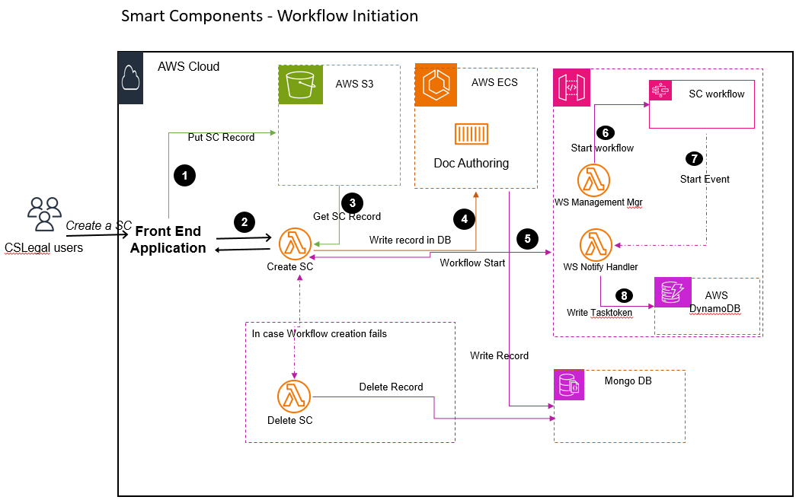

As the diagram illustrates, the UI stores the (1) Smart Component Record content in a S3 Bucket and calls the Smart Component Creation GraphQL function (2). The Lambda uses the folder id to fetch the data (3) from the S3 Bucket and passes the record (4) for record creation via a REST API call to DocumentAuthoring that in return create the record in Mongo DB Table and returns the component id assigned for the record. Lambda function calls the workflow initiation using this component id (5) via API Gateway. The Step Function workflow is initiated (6) and an event with the task token required for the next step is fired upon successful initiation (7). This task token (8) is stored in a Dynamo DB table for use by the subsequent steps.

Error handling currently in place;

- (3) Error returned in case of failure.
- (4) Error handling done in case the record cannot be created in the DB
- (5) Connection failures or Step function errors delete the newly created record and return an error message to FE.

Workflow initiation scenario 2

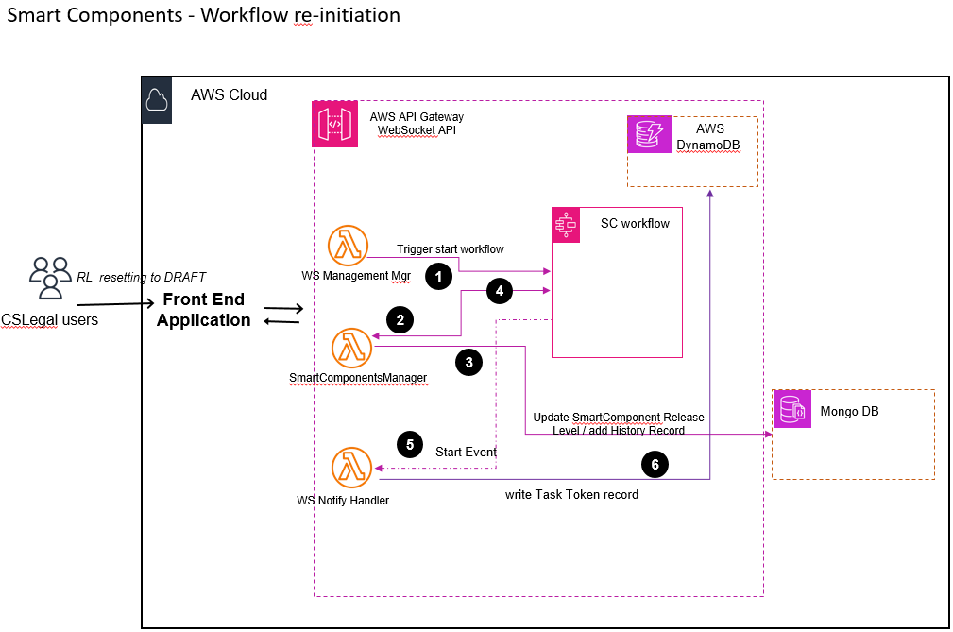

In this process, the Management Lambda triggers a “StartWorkflow” (1) towards State Machine for Workflow initiation. The State Machine activates the SmartComponentsManager lambda (2) with the payload. The SmartComponentsManager Lambda updates the Smart Component Record (3) and returns the result (4). State Machine fires an event (5) that is caught by Notify Handler Lambda. The Notify Handler Lambda writes the task token record (6) required for next step.

Error handling currently in place;

- Data Validation returns an error if any field is invalid or missing. State machine remains intact and FE application can retry with valid data.
- (3) Lambda throws an error if the Smart Component with the given component id is not in the DB. This is an exceptional case. The case needs to be simulated and the state of the state machine must be observed in order to place a suitable recovery process.

Workflow continuation

Workflow continuation is triggered by the users using release level change function. Thus this is a continuation of an already started workflow.
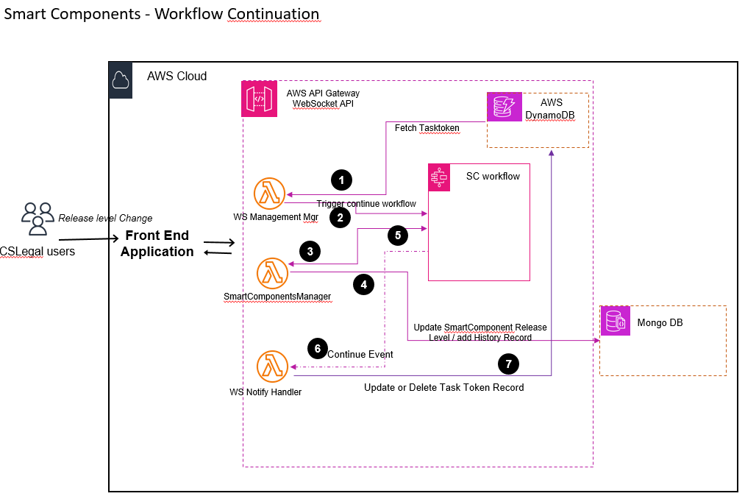
The lambda fetches the task token required to trigger the next step of the workflow (1) and triggers the workflow continuation (2). Workflow triggers Smart Components Manager lambda (3) with the received payload for further processing. This lambda updates the smart component record and generates the history record (4). It further informs the result of the processing to State Machine (5). State Machine fires an event (successful or failure) (6) that is processed by Notify Handler. Notify Handler updates the task token table in case the of release level change type 1 or deletes the task token record related to the respective smart component id (Type 2). The latter completes the workflow.

Error handling currently in place;
- Data Validation returns an error if any field is invalid or missing. State machine remains intact and FE application can retry with valid data.
- (1) Exception thrown in case the task token is not available. This is an exceptional case. A recovery process must be determined for this such as resetting the component’s release level to initial state (DRAFT).
- (4) Lambda throws an error if the Smart Component with the given component id is not in the DB. This is an exceptional case. The case needs to be simulated and the state of the state machine must be observed in order to place a suitable recovery process.

Release Levels and Transitions Definition
The MongoDB collection workflow contains a record with name “SmartComponentsWorkflow” that contains the initial release level and transition settings.
{
"_id": { "$oid": "64e75394ddc2916691151947" },
"name": "SmartComponentsWorkflow",
"releaseLevels": [
{
"descriptors": { "de": "Entwurf", "en": "Draft" },
"icon": "edit",
"iconColor": "#0067b2",
"initial": true,
"name": "DRAFT",
"checkoutPossible": true,
"transitionTargets": [ { "releaseLevelName": "TO_BE_APPROVED", "restrictions": []
} ] },
{
"descriptors": { "de": "Abgelehnt", "en": "Rejected" },
"icon": "replay",
"iconColor": "#F32F2F",
"initial": false,
"name": "REJECTED",
"transitionTargets": [ { "releaseLevelName": "DRAFT", "restrictions": []
} ] },
{
"descriptors": { "de": "Genehmigt", "en": "Approved" },
"icon": "check",
"iconColor": "#9ACD32",
"initial": false,
"name": "APPROVED",
"transitionTargets": [ { "releaseLevelName": "DRAFT", "restrictions": []
} ] },
{
"descriptors": { "de": "Zu genehmigen", "en": "To Be Approved"
},
"icon": "hourglass_empty",
"iconColor": "#F1C40F",
"initial": false,
"name": "TO_BE_APPROVED",
"transitionTargets": [ {
"releaseLevelName": "APPROVED",
"restrictions": [ {
"_t": "GROUP_RESTRICTION",
"groups": [ "TEMPLATE_EDITORS" ],
"shouldBeMemberOfGroup": true
} ] }, {
"releaseLevelName": "REJECTED",
"restrictions": [ {
"_t": "GROUP_RESTRICTION",
"groups": [ "TEMPLATE_EDITORS" ],
"shouldBeMemberOfGroup": true
} ] } ] } ]
}

Get Release Levels and Transition Info
Release level Transition information request returns information based on the settings in the record defined in Release Levels and Transitions Definition.
Two requests are available to fetch information on release level transition.

Get all available release levels

Request | listSmartComponentReleaseLevels
Request Type | GraphQL
Request Data | None
Response | {  "data": {"listSmartComponentReleaseLevels": [  {  "checkoutPossible": true,  "icon": "edit",  "iconColor": "#0067b2",  "initial": true,  "name": "DRAFT",  "descriptors": [ {"locale": "de", "text": "Entwurf"},{ "locale": "en","text": "Draft"}  ]  },  {  "checkoutPossible": null,  "icon": "replay",  "iconColor": "#F32F2F",  "initial": false,  "name": "REJECTED",  "descriptors": [ { "locale": "de","text": "Abgelehnt"},{ "locale": "en","text": "Rejected"}  ]  },  {  "checkoutPossible": null,  "icon": "check",  "iconColor": "#9ACD32",  "initial": false,  "name": "APPROVED",  "descriptors": [{"locale": "de", "text": "Genehmigt" },{ "locale": "en", "text": "Approved"}  ]  },  {  "checkoutPossible": null,  "icon": "hourglass_empty",  "iconColor": "#F1C40F",  "initial": false,  "name": "TO_BE_APPROVED",  "descriptors": [{"locale": "de","text": "Zu genehmigen"},{"locale": "en","text": "To Be Approved"}  ]  }]}}
Description | Returns all defined release levels

Get the next transition level for a component

Request | /smart-components/transitions/componentId
Request Type | REST API (GET )
Request Data | Component id
Response | [  {  "name": "DRAFT",  "icon": "edit",  "iconColor": "#0067b2",  "descriptors": {  "de": "Entwurf",  "en": "Draft"  },  "checkoutPossible": true  }  ]
Description | Returns next release level (DRAFT) as the current release level of the given component is APPROVED

Release level transition permissions

Release level transition permissions are set in the release level definition record. See Release Levels and Transitions Definition. The record example allows release level transition from TO_BE_APPROVED to APPROVED or REJECTED only to TEMPLATE EDITORS group members.

Workflow API
Front Application accesses Workflow API using web socket connections via API Gateway.
Web Socket Address is set together as follow;
wss://service_domain_proxy/workflow
Whereas service_domain_proxy is the AWS Service Domain, e.g.: develop.cslegal.services in the CSLegal Service Domain of the Development Environment.

Request Authentication

The interface authenticates the request by the access token that is enclosed in the Web Socket URL. Hence the URL with the access token will be as follows;
wss://service_domain_proxy/workflow?token=Access Token

Actions
Two types of actions identify the operation type in the workflow:
Action Type | Operation
startWorkflow | Is used to initiate the workflow and if applicable, to set the release level to DRAFT
continueWorkflow | Is used to continue with an existing workflow, that is e.g. to set a Release Level from DRAFT to TO_BE_APPROVED etc. (see Type 1 and 2 in the release level change table)

Payloads

Release Level transition |  | Request Payload | Response Payload
From | to | Request Payload | Response Payload
APPROVED,  REJECTED | DRAFT | {  “action”: “startWorkflow”,  "componentId": "componentId",  "releaseLevel": "DRAFT",  "releaseLevelComment": "Any comment"  } | {  "componentId": "componentId",  "releaseLevel": "DRAFT",  "releaseLevelComment": "Any Comment",  "time": "YYYY-MM-DDTHH:MM.SS.mmmZ",  "username": "Username",  "successful": true or false  }
DRAFT | TO_BE_APPROVED | {  “action”: “continueWorkflow”,  "componentId": "componentId",  "releaseLevel": "TO_BE_APPROVED",  "releaseLevelComment": "Any comment"  } | {  "componentId": "componentId",  "releaseLevel": "TO_BE_APPROVED",  "releaseLevelComment": "Any Comment",  "time": "YYYY-MM-DDTHH:MM.SS.mmmZ",  "username": "Username",  "successful": true or false  }
TO_BE_APPROVED | APPROVED | {  “action”: “continueWorkflow”,  "componentId": "componentId",  "releaseLevel": "APPROVED",  “approved”: true,  "releaseLevelComment": "Any comment"  } | {  "componentId": "componentId",  "releaseLevel": "APPROVED",  "releaseLevelComment": "Any Comment",  "time": "YYYY-MM-DDTHH:MM.SS.mmmZ",  "username": "Username",  "successful": true or false  }
TO_BE_APPROVED | REJECTED | {  “action”: “continueWorkflow”,  "componentId": "componentId",  "releaseLevel": "REJECTED",  “approved”: false,  "releaseLevelComment": "Any comment"  } | {  "componentId": "componentId",  "releaseLevel": "REJECTED",  "releaseLevelComment": "Any Comment",  "time": "YYYY-MM-DDTHH:MM.SS.mmmZ",  "username": "Username",  "successful": true or false  }

Notes:
- The field “releaseLevelComment” may be left blank or completely ignored except in the REJECTED request.
- The field “approved” must be set to true in the APPROVED request.
- Likewise, the field “approved” must be set to false in the REJECTED request.

Status code returned are (see http Status Codes).

Validation Error response payload
The request validation layer (prior to the payload passed to step functions layer) raises Validation Errors as exceptions with the error message. The state machine is not broken in this case so that the user may retry the request with correct data.
The response payload in this case generally contains following data:
{
"message": "Internal server error",
"connectionId": "connection id",
"requestId": "request id"
}

Validation Errors

Error Message | Reason
Authentication failed. No token present in the connect request | The access token provided is incorrect or no token is present
Workflow already exist for this id: component_id, Release Level: current_release_level, Try continuing it with next level | User tries to start a workflow with the component_id, but a workflow is already started with the given component id and it is currently in the given current_release_level.
Tasktoken not found for component Id | User sends continueWorkflow request for the given component id. The validation layer is unable to fetch the required task token for the next step.
The component id cannot be empty | User sends a request without a component id in the payload.
Smart Component not found for updating. ComponentId: component_id | The record with the given component id is not found in the Database.
release level is not valid | The release level name in the request is wrong.
release level release_level is already set. | The request contains a release level that is already set in the given smart component record.
release level release_level_in_payload is not valid as next level for release_level_in_DB | The request contains a release level that is not valid as the next release level.
The release level is invalid, must be DRAFT | The user sends a startWorkflow request with a release level other than DRAFT
Boolean value value of field approved does not match with release_level | User sends either REJECTED or APPROVED request, but the value in the “approved” field does not match with it. (APPROVED = true, REJECTED = false)
releaseLevelComment is not set, it is compulsory for REJECTED release level | The payload of the REJECTED request doesn’t contain the compulsory releaseLevelComment.

Operational Concept
The Smart Component workflow is designed to provide a secure, flexible and well-arranged process to users of the system. This section describes the operational concept with regard to workflow part of smart components.

Intended Users

Smart Components Editors
SC Editors creates a smart component and edit its contents. They must have all permissions within the DRAFT release level in order to perform all CRUD operations within this release level.
SC Editors sets the smart component to next release level (to be approved) once the smart component is satisfactorily completed. They may not have permission to perform any other operations in this release level.

Smart Components Owners (Authors)
The authors of the smart components, or the owners of SCs, receives a notice that SCs are ready for approval. They inspect the SC, may do themselves minor changes and approves the SC. They may reject the SC with a comment, re-take it to draft release level and reassign to Editor if major changes need to be done in the respective SC.
These users must have all permissions within the TO_BE_APPROVED and APPROVED, REJECTED release levels.
The SC is ready to be used in templates when they are in the approved state.

Appendix

AWS Services
The following table contains information about the services deployed for smart components workflow.
Name | Description
Workflow | Step functions workflow State machine.
Workflow | Service: Step Functions
Workflow | IaC script; lib/csLegalConstructs/csLegalSmartComponents.ts
Workflow | LogGroup name: SmartComponentsWorkflowLogGroup
Workflow | Timeout: 30 days (see serviceConfigurations WorkflowParameters.ts)
AuthorizerHandler | WebSocket connection authentication check
AuthorizerHandler | Service: Lambda
AuthorizerHandler | IaC script; lib/csLegalConstructs/cslegalSmartComponentsWebSocketAPI.ts
AuthorizerHandler | description: WebSocketAPi authorization
AuthorizerHandler | Timeout: 3 seconds
WebsocketManagementManager | Websocket request entry point.
WebsocketManagementManager | Service: Lambda
WebsocketManagementManager | IaC script; lib/csLegalConstructs/cslegalSmartComponentsWebSocketAPI.ts
WebsocketManagementManager | description: Websocket Management Manager for Smart Components
WebsocketManagementManager | Timeout: 3 seconds
SmartComponentsManager | Database update.
SmartComponentsManager | Service: Lambda
SmartComponentsManager | IaC script; lib/csLegalConstructs/csLegalSmartComponents.ts
SmartComponentsManager | description: Release Levels Setting Function for Smart Components (./src/Components/SmartComponentsManager)
SmartComponentsManager | Timeout: 3 seconds
NotifyHandler | Step functions notifications handler.
NotifyHandler | Service: Lambda
NotifyHandler | IaC script; lib/csLegalConstructs/cslegalSmartComponentsWebSocketAPI.ts
NotifyHandler | description: Notify Handler for Smart Components
NotifyHandler | Timeout: 3 seconds

Configuration parameters
Workflow relevant configuration parameters are placed in
configurations/serviceConfigurations/{environment_id}/WorkflowParameters.ts
file in the backend application.

Parameter Name | Description
stateMachineTimeout | Workflow State Machine timeout in number of days.
 | Intentionally left blank for future additions.

Troubleshooting
Cause of failures can be investigated using logs and info at various points. Following CloudWatch logs are available:
Service | Name / Description | Description
Step Functions | csLegalSmartComponentsStackWorkflow | Step functions workflow State machine. (CouldWatch Logs)  Check if the workflow was triggered with componentId and username, check if “TaskSucceeded” entry exists
Lambda | WebSocketAPi authorization | Perform WebSocket authentication check.  Entry may exist if authorization fails.
Lambda | Websocket Management Manager for Smart Components | Websocket request entry point. Any failures prior to start / continue with the workflow may be reported here.
Lambda | Release Levels Setting Function for Smart Components.. | Any failure occurred while updating the database.
Lambda | Notify Handler for Smart Components | Any failure occurred after the state is completed.

Outstanding issues of the current implementation
Following is a list of flaws / outstanding issues that is however not conclusive.
Workflow (State machine) termination due to external conditions
Several external conditions such as network failure, DB read/write failure, code bugs in lambda functions may cause that the state machine terminates abnormally in the middle of the workflow. Number of recovery mechanisms are implemented for some stages. However not every possible points of failure are tested yet and remedies are open.
Workflow (State machine) termination due to timeouts
State machine instances initiated per workflow of smart components are subject to expire after certain number of days determined. The state machine is stopped automatically when this is reached. These events are yet to be handled and clean-up processes must be determined.
Hard-coded release level validations
The backend project contains IaC scripts required to deploy the state machine for workflow. These IaC scripts must be customized if a customer requires a different workflow than the standard one defined here. The release level validations in Lambda functions are hard-coded currently.
Release level transition permission validations
The backend applications do not validate release level transition permissions currently.
Task-token management
Task-token is an element in AWS Step functions that identifies an already initiated and hence started state machine instance of a given smart component. This task token is currently handled solely by the backend application and stored in a separate DynamoDB collection. This is inefficient as additional read / delete steps incur.

Future developments
Workflow (State machine) re-drive to recover from failures
Investigate state machines recovery from failures mechanisms and implement them. See also https://aws.amazon.com/de/blogs/compute/introducing-aws-step-functions-redrive-a-new-way-to-restart-workflows
Workflow (State machine) timeouts handling
Timeout of a state machine instance generates an event. The release level of the smart component shall automatically be set to “rejected” and relevant tasks shall be performed based on this event.
Release level validation and permission check
Backend Application shall use the SmartComponentsWorkflow record in the workflow collection for validating release levels and checking permissions for release level transitions.
Task-token management
Task-token related to a particular smart component shall be set as a field within the respective smart component record. This will reduce the number of MongoDB collections that need to be maintained, reduce the steps to perform SC workflow operations, reduce points of failures and improve the performance. Frontend application handles adding, updating and deleting task token fetching it from the response payload. It appends the request payload by the task token getting it from smart component record.
Smart Component deletion handling
This is the counter piece of state machine timeout handling. State machine clean-up operations need to be performed in case a smart component with active workflow is deleted.

